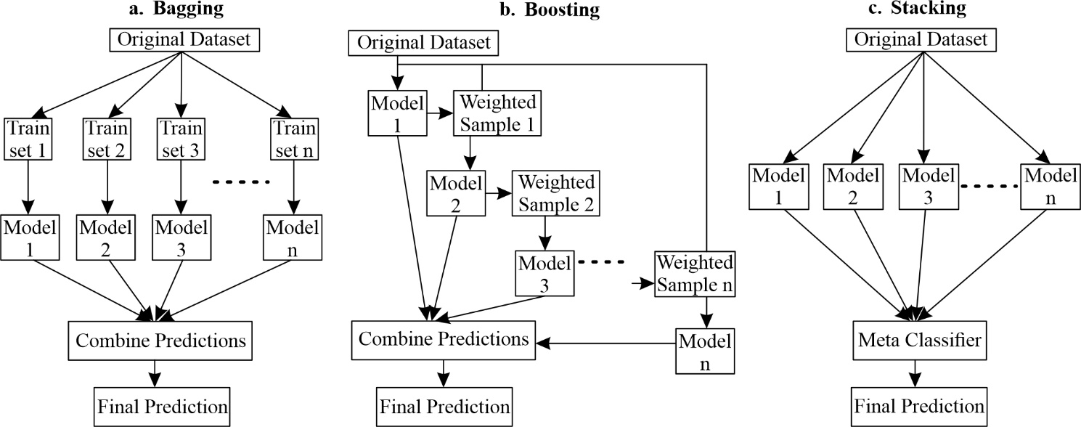
Figure 1 Block diagram of ensemble models based on a. Bagging, b. Boosting, c. Stacking (Adapted from https://mlarchive.com/machine-learning/ensemble-learning-for-predictive-models/)

Table 1. Hyperparameters for each model.
Model | Hyperparamter | Value
XGBoost | nrounds | 30
 | eta | 0.266
 | max_depth | 7.0
 | subsample | 0.997
 | colsample_bytree | 0.897
AdaBoost | mfinal | 112
 | cp | 0.001
 | maxdepth | 13
Random Forest | ntree | 500
 | mtry | 3
 | nodesize | 1
 | maxnodes | 500

Table 2. Model performance for the prediction of Zn-Pb deposit types
Model performance | Accuracy | Precision |  | Recall | Specificity | F1-score | Cohen's Kappa | MCC
XGBoost | 85.29 |  | 86.78 | 84.55 | 95.77 | 86.65 | 79.07 | 79.08
Random Forest | 86.16 |  | 87.67 | 87.28 | 96.03 | 87.47 | 80.29 | 80.30
AdaBoost | 84.43 |  | 82.99 | 88.10 | 95.44 | 85.47 | 77.64 | 77.72

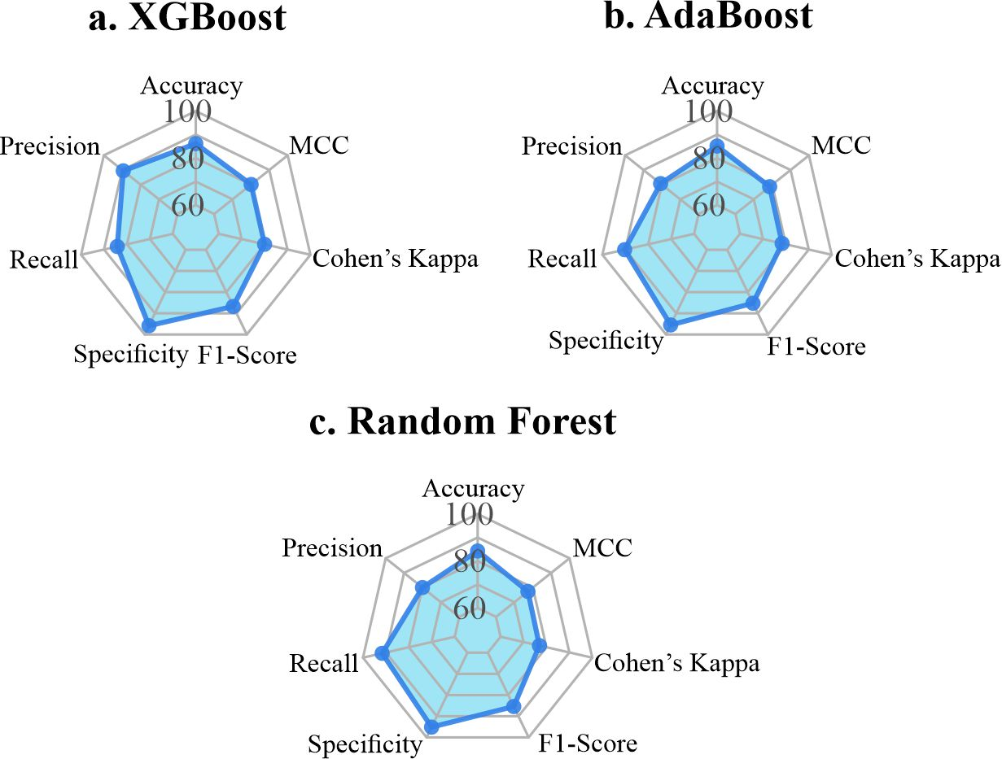
Figure 2. Radar charts emphasizing the comparative strength of some models in terms of evaluation metrics.

